**Docker 2**

1. **Installing and enabling docker inside Ubuntu terminal & Connecting ubuntu terminal with GUI based portainer**

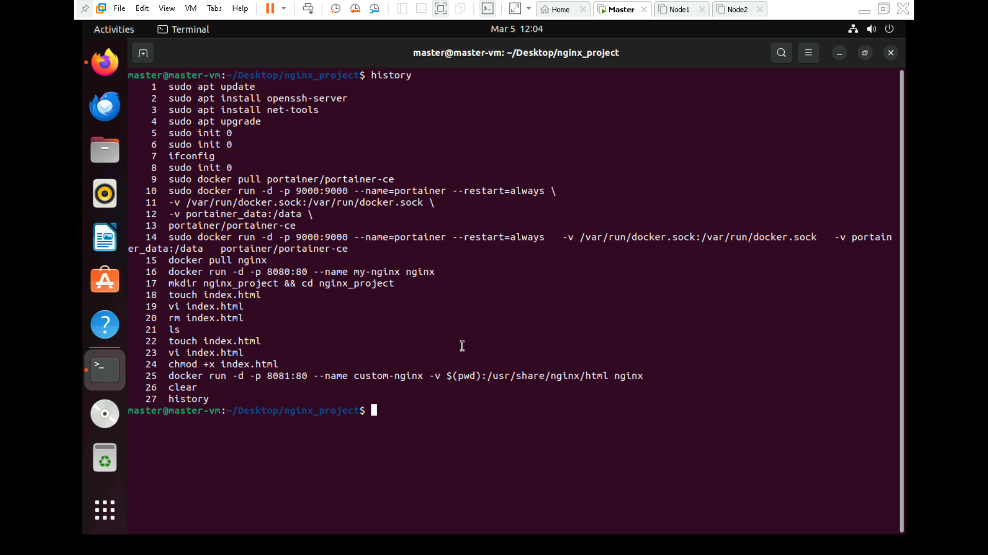

1. **Go to** [**http://localhost:9000**](http://localhost:9000) **and set the password**
2. **Deploy an Nginx Web Server with Docker**
3. **Open** [**http://localhost:8080**](http://localhost:8080) **and we will see default Nginx welcome page.**
4. **Then Create Customized Nginx with own HTML page**
5. **Refresh** [**http://localhost:8081**](http://localhost:8081) **and we will see the customer page.**
6. **Output**

